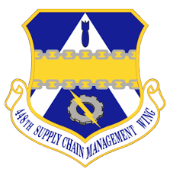

SASPO – Hill Industry Day Agenda

Location: Weber State University Ogden
3848 Harrison Blvd
Ogden, Utah 84408
Sheperd Union Building Ballroom C
Date: December 7, 2023
Time: 0800-1400 hrs. MT

Agenda Items

0800-0810 Opening Remarks by the 748th SCMG Commander Col. Boschert
0810-0900 Squadrons 414th, 415th, 416th, 417th, 419th 0900-0920 KC-46 Future Opportunities 424th SCMS/GUMD
0920-1000 Networking Break
- Meet with SASPO, AF Engineers, Complex, KC-46 Team,
and other members of Industry.

1000-1020 Hill Small Business Office Mr. R. Shon Stevenson
1020-1040 APEX Accelerators Mr. Chuck Spence
1040-1055 Commercially Used & Overhauled Mr. Brian Butler
1055-1110 Reverse Engineering & Repair Development Mr. Stephen Benjamin
1110-1130 Other Transaction Authority (OTA) – 448th SCCI Mr. Brian Butler
1130-1230 Break for Lunch
1230-1250 Weapon System Opportunities Mr. Stephen Benjamin
1250-1330 Networking Break
- Meet with SASPO, AF Engineers, Complex, KC-46 Team,
and other members of Industry.
1330-1400 Source Approval Request (SAR) Training Mr. Jonathan Mason
1400 Closing Remarks Mr. Stephen Benjamin

